**Topic: Recurrent Neural Network (RNN)**

**Instructions**

Please share your answers filled inline in the word document. Submit Python code and R code files wherever applicable.

Please ensure you update all the details:

**Name:**

**Batch Id:**

**Topic: Recurrent Neural Network.**

1. **Business Problem**
   1. **Objective**
   2. **Constraints (if any)**
2. **Work on each feature of the dataset to create a data dictionary as displayed in the below image:**

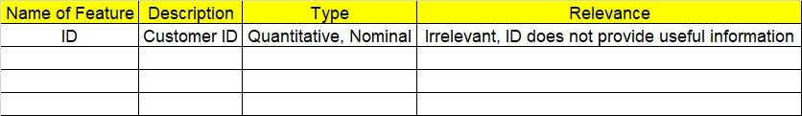

**2.1 Make a table as shown above and provide information about the features such as its Data type and its relevance to the model building, if not relevant provide reasons and provide description of the feature.**

**Using Python code perform:**

1. **Data Pre-processing**

**3.1 Data Cleaning, Feature Engineering, etc.**

**3.2 Outlier Imputation if applicable**

1. **Model Building**
   1. **Build the Recurrent Neural Network**
   2. **Train and Test the data**
   3. **Briefly explain the model output in the documentation**
2. **Share the benefits/impact of the solution - how or in what way the business (client) gets benefit from the solution provided**
3. **Use Tensorflow for this assignment depending on your system configuration either Tensorflowgpu or Tensorflowcpu version.**

# Note:

**The assignment should be submitted in the following format:**

* **Python code**
* **Code Modularization should be maintained**
* **Documentation of the model building (elaborating on steps mentioned above)**

**Standard Grading Guideline :**

Grade A: All assignments submitted correctly on Time (with all mentioned content like: python code, r code, documentation)

Grade B: All assignments submitted but post the due date. Or Partial assignments are submitted.

Grade C and Grade D: Partial assignments submitted with incorrect answers, or worked on only R or Python or not all the content is submitted.

Grade F: Partial assignments submitted with incorrect answers and not all the content is submitted.

**Problem Statement:-**

1. Here is the time series data [110,125,133,146,158,172,187,196,210].

Build RNN/LSTM model to predict the next 10 digits.

2. Write down the multiple applications of RNN.

3. How to do select the inputs for a LSTM/RNN models. Explain in the terms of timesteps, samples and feature.

4. What are the disadvantages of MLP when dealing with sequence data.